Subject 04 data analysis_bad order 08june2011, 13oct2011

NOTE NOTE from 01nov2011… the date for DF=4 5 6 (from multiple trials in Oct 2011) had mis-arranged results from multiple trials into wrong components of result.data… On 01nov2011 JR re-arranged correctly. The analysis of those original data are stored here in Subject 04_data analysis_bad order.doc The data far below here for DF =3 and 7 are OK.

DF=6
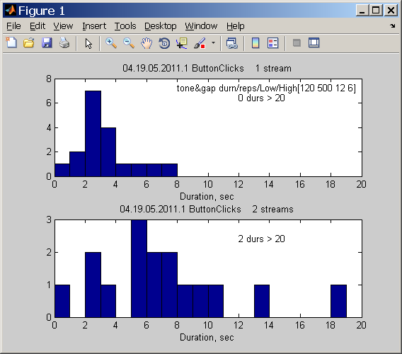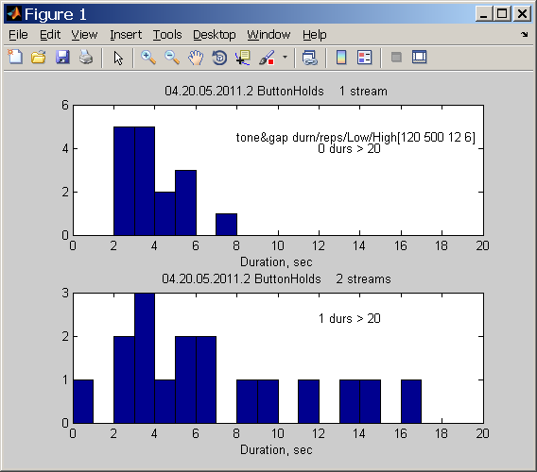
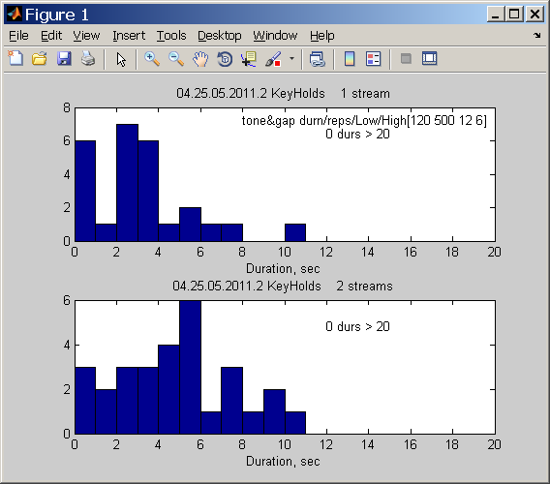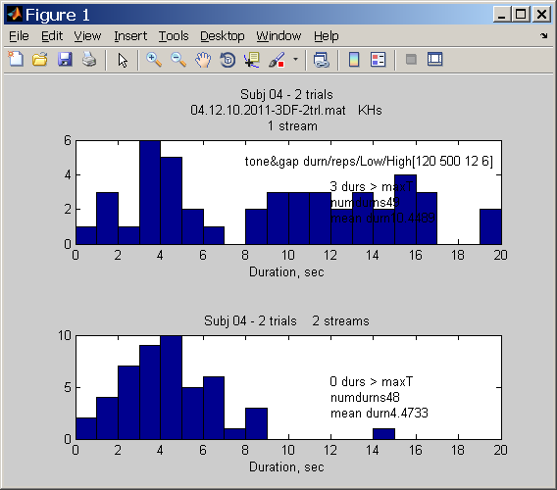these data for DF=6 in 04.12.10.2011… are superceded by data/plot just below. All 3 cond’ns and 2 trials are stored in
04.13.10.2011_3DF_2trl.mat . JR redid this case DF=6. NOTE: subj 04 reported post-run that there were some patterns sounding not like 2-streams or HLH_HLH… triplet but rather like doublets: LH_LH_LH_ …

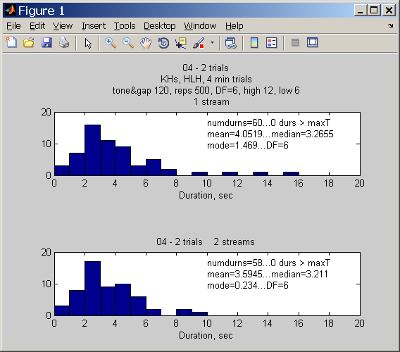

DF=5
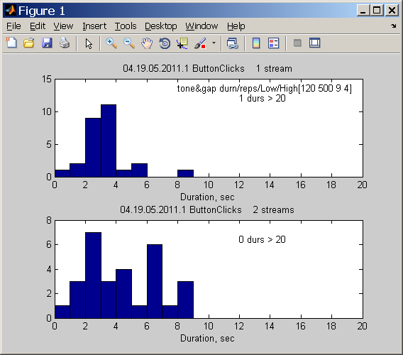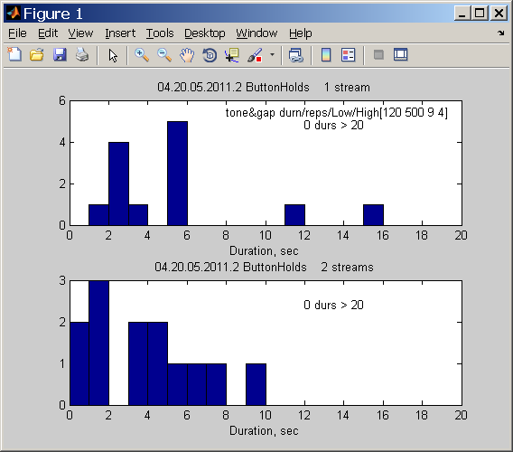
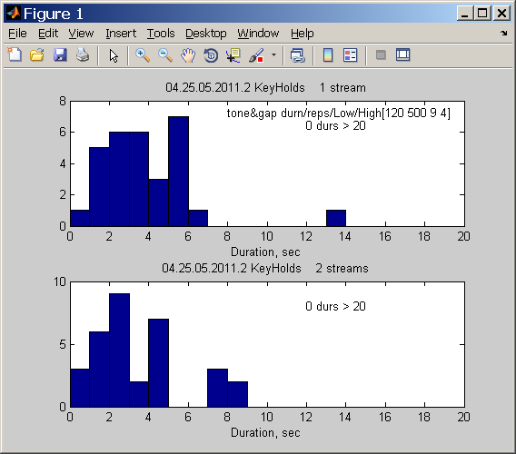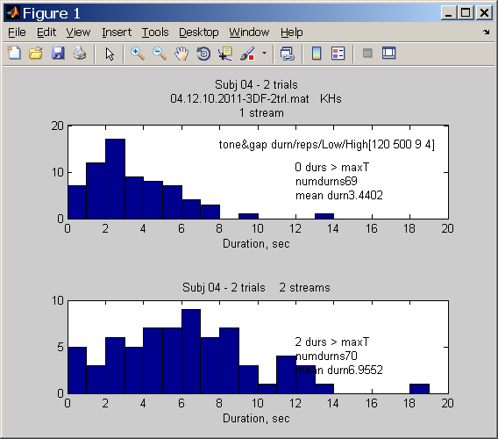

DF=4

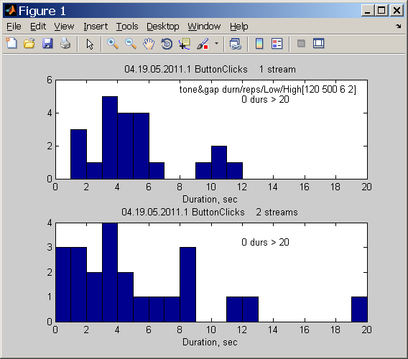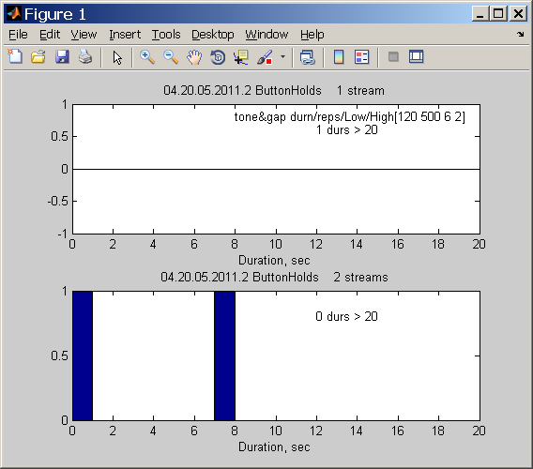
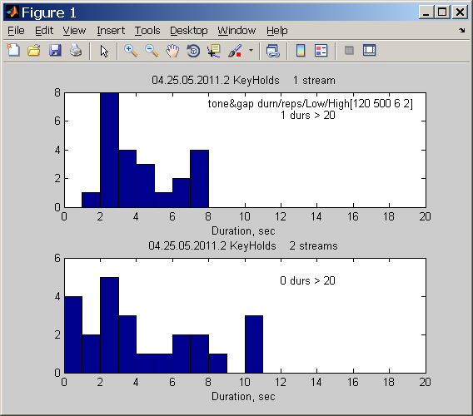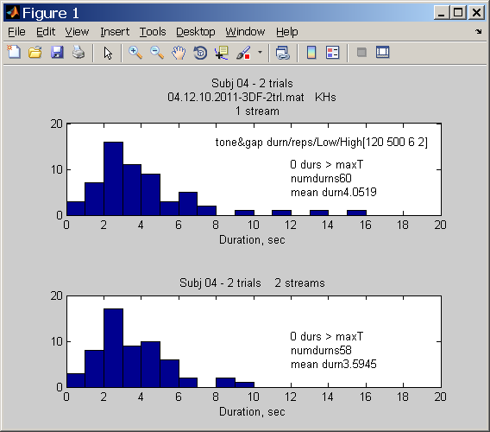
Subject 04 data analysis 08june2011
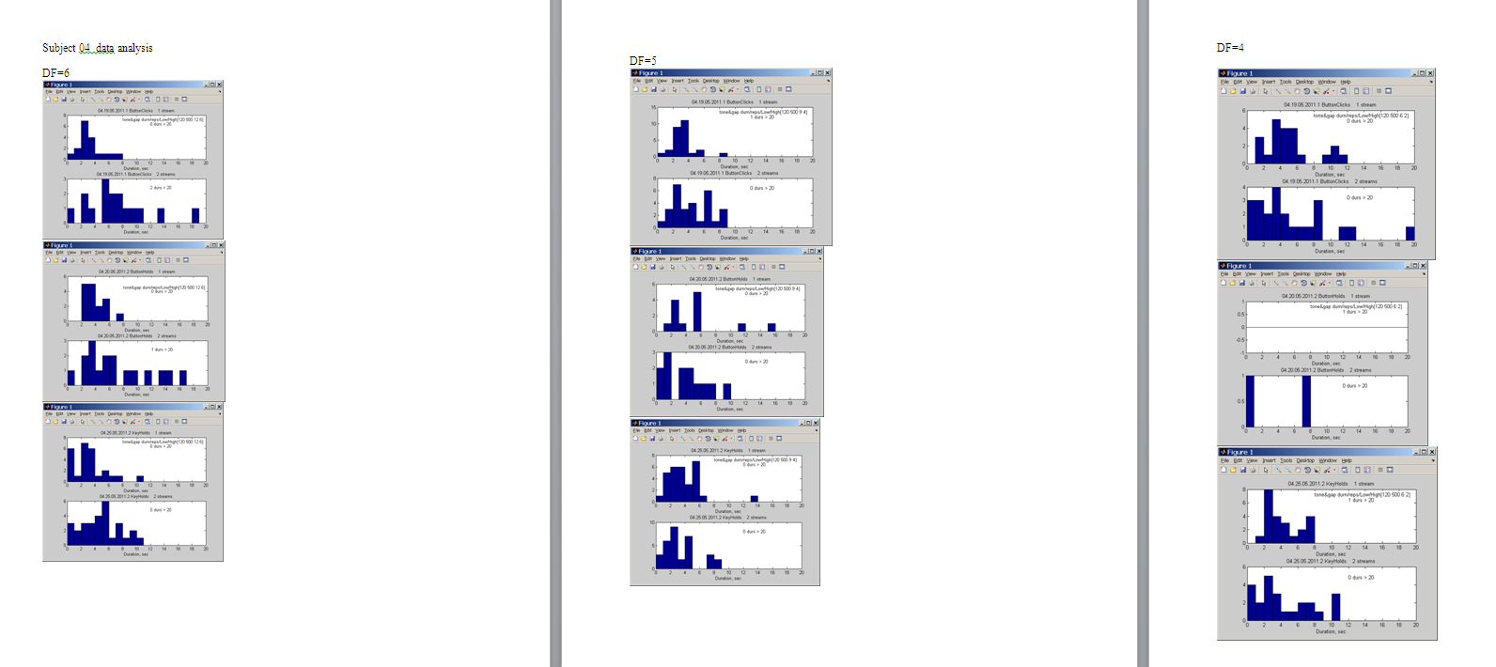

Summary data for 3 trials from
04.25.05.2011.2.mat and from 04.13.10.2011_3DF_2trl.mat
Combined in
Rnet04.mat

DF=3 3 trials.

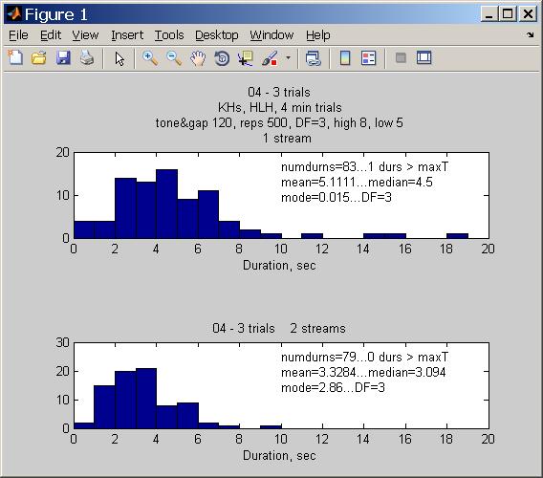
Stats for --04 - 3 trials...DF=3

83.0000 5.1111 4.5000 0.0150
79.0000 3.3284 3.0940 2.8600

DF=4 3 trials.
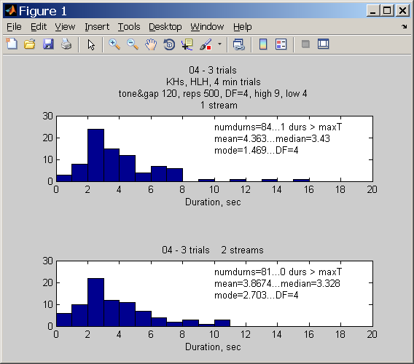
Stats for --04 - 3 trials...DF=4

84.0000 4.3630 3.4300 1.4690
81.0000 3.8674 3.3280 2.7030

DF=5. 3 trials.

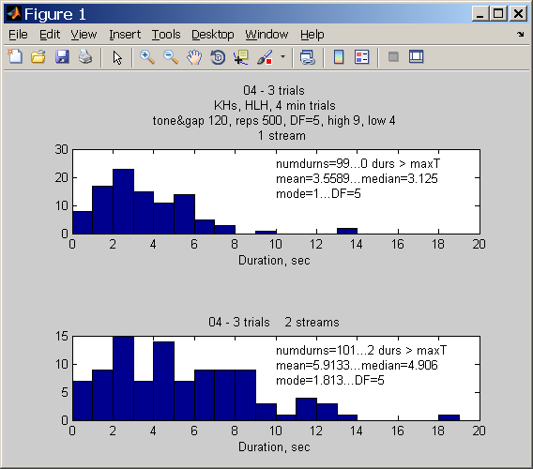
Stats for --04 - 3 trials...DF=5

99.0000 3.5589 3.1250 1.0000
101.0000 5.9133 4.9060 1.8130

DF=6. 3 trials.

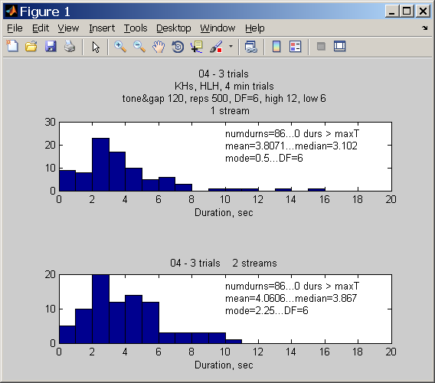

Stats for subj: 04 - 3 trials...DF=6

86.0000 3.8071 3.1020 0.5000
86.0000 4.0606 3.8670 2.2500

DF=7, 3 trials.
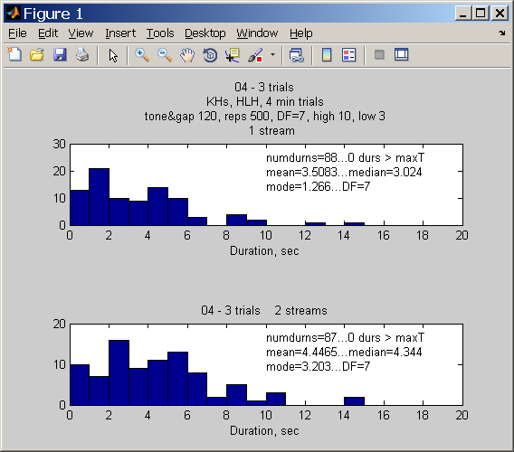

Stats for --04 - 3 trials...DF=7

88.0000 3.5083 3.0240 1.2660
87.0000 4.4465 4.3440 3.2030

+++++++++++
++++++++++++

